Light - 09
CLASS 10 - SCIENCE

 | Section A
1 | Which colour of light has the longest wavelength?  a) Violet  b) Green  c) Yellow  d) Red | [1]
2 | It is found that all the light rays sent from X towards Y reach point Z inside the glass sphere, as shown in figure. The speed of rays in glass cannot be 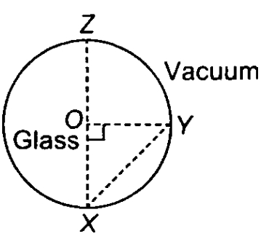  a) 2.4$×$ 10 $​^{8}$ m s $​^{−1}$  b) 4$×$ 10 $​^{7}$ m s $​^{−1}$  c) 1.7$×$ 10 $​^{7}$ m s $​^{−1}$  d) 1.0$×$ 10 $​^{8}$ m s $​^{−1}$ | [1]
3 | A bundle of light rays is called a  a) Arrows of light  b) Pool of light  c) Beam of light  d) Bunch of light | [1]
4 | The lateral displacement of an incident ray passing out of a rectangular glass slab  a) independent of the thickness of the glass slab.  b) None of these  c) is directly proportional to the thickness of the glass slab.  d) inversely proportional to the thickness of the glass slab. | [1]
5 | A sharp image of a distant object is obtained on a screen by using a convex lens. In order to determine the focal length of the lens, you need to measure the distance between the  a) lens and the object  b) object and the screen  c) lens and the screen  d) None of these | [1]
6 | Four optical media W, X, Y and Z have optical densities 1.35, 1.21, 1.58 and 1.002 respectively. In which optical medium will the light travel fastest?  a) W  b) Y  c) Z  d) X | [1]
7 | The angle of reflection is equal to the angle of incidence:  a) sometimes  b) always  c) never  d) under special conditions | [1]
8 | If the angle of incidence is 90$​^{o}$ , what is the angle of refraction?  a) r = 1$​^{o}$  b) r = 45$​^{o}$  c) r =sin - 1$\left(\frac{1}{n}\right)$  d) r = 90$​^{o}$ | [1]
9 | Which of the following can be used to find the focal length of a lens?  a) object at a distance of 10 cm for a focal length of 30 cm  b) light from window of our lab  c) light from sun  d) light from a distant tree | [1]
10 | Which one of the following materials cannot be used to make a lens?  a) Clay  b) Plastic  c) Water  d) Glass | [1]
11 | Dispersion of light takes place due to:  a) The difference in refracting surface  b) The difference in the wavelength  c) The difference in colour of light  d) The difference in the nature of light | [1]
12 | Refractive indices of water, sulphuric acid, glass, and carbon disulphide are 1.33, 1.43, 1.53, 1.63 respectively. The light travels slowest in:  a) sulphutics acid  b) water  c) glass  d) carbon disulphide | [1]
13 | If e and i are the emergent and incident angles, then for a rectangular glass slab  a) e =$\frac{i}{2}$  b) e = 2i  c) e = i  d) e > i | [1]
14 | On covering a portion of a lens with a black sheet:  a) size depending on the coverage area  b) a full image is formed  c) full image of reduced brightness is formed  d) full image of increased brightness is formed | [1]
15 | The image formed by a plane mirror is:  a) real, behind the mirror, and of the same size as the object  b) virtual, behind the mirror, and of the same size as the object  c) virtual, behind the mirror, and enlarged  d) real, at the surface of the mirror, and enlarged | [1]
16 | The angle to which an incident ray at an angle$θ$ deviates on getting reflected from a surface are  a) 180 - $θ$  b) 180 - 2$θ$  c) 2$θ$  d) $θ$ | [1]
17 | With an increase in the thickness glass slab the lateral displacement:  a) remains same  b) increases  c) decreases  d) zero | [1]
18 | If f$​_{1}$ and f $​_{2}$ are the focal lengths of two lenses, what is the relation for equivalent focal length?  a) $\frac{2\left(f_{1}+f_{2}\right)}{2f_{1}×f_{2}}$  b) $\frac{f_{1}×f_{2}}{f_{1}+f_{2}}$  c) $\frac{2f_{1}×f_{2}}{f_{1}+f_{2}}$  d) $\frac{f_{1}+f_{2}}{f1×f2}$ | [1]
19 | In an optics experiment, with the position of the object fixed, a student varies the position of a convex lens. A graph between the object distance u and the image distance v, from the lens, is plotted using the same scale for the two axes. A straight line passing through the origin and making an angle of 45$​^{o}$ with the x - axis meets the experimental curve at P. The coordinates of P will be  a) (f, f)  b) (4f, 4f)  c) $\left(\frac{f}{2},\frac{f}{2}\right)$  d) (2f, 2f) | [1]
20 | The refractive index of glass for light going from air to glass is$\frac{3}{2}$ . The refractive index for light going from glass to air will be:  a) $\frac{4}{6}$  b) $\frac{5}{2}$  c) $\frac{4}{5}$  d) $\frac{1}{3}$ | [1]
21 | No matter how far you stand from a mirror, your image appears erect. The mirror is likely to be :  a) Either plane or convex  b) Convex  c) Plane  d) Concave | [1]
22 | The refractive indices of four media A, B, C, and D are 1.44, 1.52, 1.65, and 1.36 respectively. When light travelling in air is incident in these media at equal angles, the angle of refraction will be the minimum:  a) in medium B  b) in medium C  c) in medium A  d) in medium D | [1]
23 | A rectangular block of glass PQRS has a refractive index 1.6 and the critical angle for the glass air interface is 39$​^{o}$ . A pin is placed midway on the face PQ. When observed from the face PS the pin shall 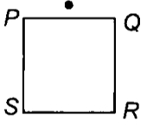  a) Appear to be near P always  b) None of these  c) Appear to be at the centre of PS  d) Appear to be near S | [1]
24 | The focal length of a convex lens depends on:  a) Colour of the light  b) The material index  c) All of these  d) Radius of the surfaces | [1]
25 | The light from a distant object on passing through the convex lens (f - focal length):  a) converges at 2f  b) appears to diverge from focus  c) converges at focus (f)  d) appears to diverge from 2f | [1]
 | Section B
26 | A student performs an experiment on ’tracing the path of a ray of light passing through a rectangular glass slab "for different values of angle of incidence. He fixes pins P$​_{3}$ and P $​_{4}$ , while looking through the face DC, so that their feet are in line with the images of the feet of the pins P $​_{1}$ and P $​_{2}$ : 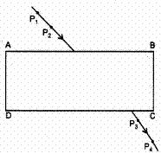  a) neither the feet nor the heads of the images of pins P$​_{3}$ and P $​_{4}$ are in line with the feet and heads, respectively, of pins P $​_{1}$ and P $​_{2}$ .  b) only the heads of the images of pins P$​_{3}$ and P $​_{4}$ are in line with the heads of pins P $​_{1}$ and P $​_{2}$  c) feet, as well as the heads of the images of pins P$​_{3}$ and P $​_{4}$ are in line with the feet and heads respectively of pins P $​_{1}$ and P $​_{2}$  d) only the feet of the images of pins P$​_{3}$ and P $​_{4}$ are in line with the feet of pins P $​_{1}$ and P $​_{2}$ | [1]
27 | Parallel rays, from a distant tree, incident on the device X, from its distinct image on a screen as shown. The diagram, correctly showing the image of the tree on the screen, is diagram: 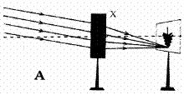  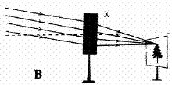  a) A and the device X is a concave mirror  b) A and the device X is a convex lens  c) B and the device X is a convex lens  d) B and the device X is a concave mirror | [1]
28 | A student obtains a sharp image of the distant window (W) of the school laboratory on the screen (S) using the given concave mirror (M) to determine its focal length. Which of the following distance should he measure to get the focal length of the mirror? 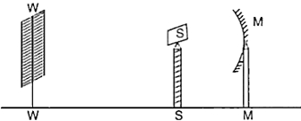  a) MW - MS  b) MS  c) SW  d) MW | [1]
29 | Which of the following ray diagrams is correct for the ray of light incident on a lens shown in Fig.? 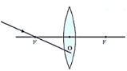  a) 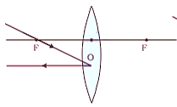  b) 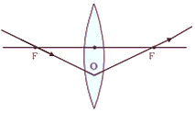  c) 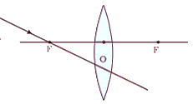  d) 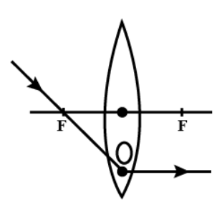 | [1]
30 | Beams of light are incident through the holes C and D respectively as shown in the figure. Which of the following could be inside the box? 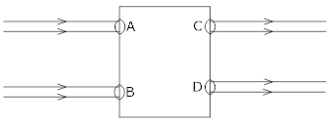  a) A rectangular glass slab  b) Convex lens  c) Concave lens  d) Prism | [1]
31 | The focal length of the concave mirror in the experimental set up, shown below, equals 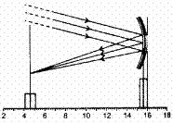  a) 10.3 cm  b) 11.0 cm  c) 12.2 cm  d) 1.7 cm | [1]
32 | Four students A, B, C, and D carried out measurement of the focal length of a concave mirror as shown in the following four diagrams. 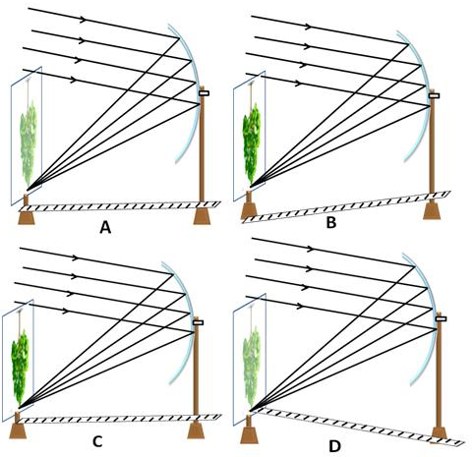  The best result will be obtained by the student:  a) A  b) B  c) D  d) C | [1]
33 | Out of the four rays shown to fall on the concave mirror, the incorrect one is: 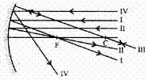  a) I  b) IV  c) III  d) II | [1]
34 | A student determines the focal length of a device X, by focusing the image of a far off object on the screen positioned as shown in the figure below: 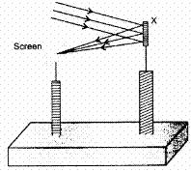  The device X is a :  a) Convex mirror  b) Concave mirror  c) Concave lens  d) Convex lens | [1]
35 | A beam of light is incident through the holes on side A and emerges out of the holes on the other face of the box as shown in the Figure. Which of the following could be inside the box? 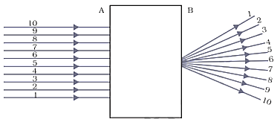  a) Prism  b) Concave lens  c) Convex lens  d) Rectangular glass slab | [1]
36 | As light IM is incident on the surface PQ, as shown the emergent ray has to be: 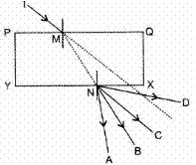  a) ND  b) NC  c) NB  d) NA | [1]
37 | The path of a ray of light coming from air passing through a rectangular glass slab traced by four students are shown as A, B, C, and D in Figure. Which one of them is correct? 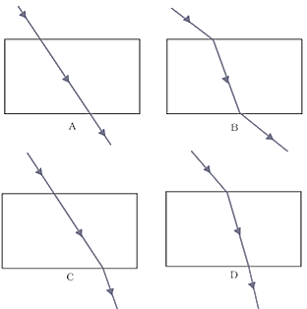  a) B  b) C  c) D  d) A | [1]
38 | The figure given alongside shows the image of a clock as seen in a plane mirror. The correct time is: 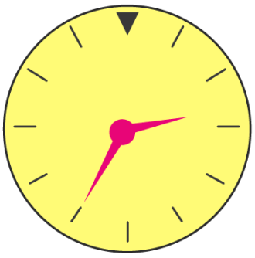  a) 2.35  b) 9.25  c) 2.25  d) 6.45 | [1]
39 | A student traces the path of a ray of light passing through a rectangular glass slab for three different values of angle of incidence (i) namely 30$​^{o}$ , 45 $​^{o}$ , 60 $​^{o}$ . He produces the incident ray and measures the perpendicular distance, l, between the produced incident ray and the emergent ray. 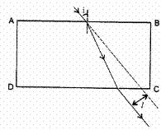  He will observe that  a) ’ l ’ keeps on increasing with increase in angle of incidence.  b) ’l’ keeps on decreasing with increase in angle of incidence.  c) ’l’ remains the same for all three angles of incidence.  d) ’l’ is maximum for$∠$ i = 45 $​^{o}$ and is less than this value both for $∠$ i = 30 $​^{o}$ and for $∠$ i = 60 $​^{o}$ . | [1]
40 | A light ray enters from medium A to medium B as shown in Figure. The refractive index of medium B relative to A will be 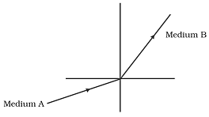  a) equal to unity  b) greater than unity  c) less than unity  d) zero | [1]
41 | Which of the following ray diagrams is correct for the ray of light incident on a concave mirror as shown in the figure? 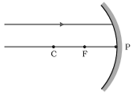  a) 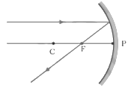  b) 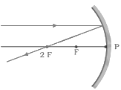  c) 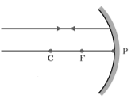  d) 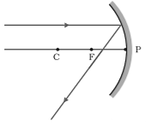 | [1]
42 | The ’D’ (protractor) used for measuring the angle of incidence (i) and the angle of reflection (r) , has to be positioned in the ways illustrated in figures: For angle of incidence For angle of reflection 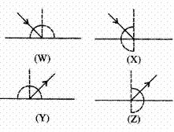  a) X and Y respectively  b) W and Z respectively  c) X and Z respectively  d) W and Y respectively | [1]
43 | The correct sequencing of angle of incidence, angle of emergence, angle of refraction and lateral displacement shown in the following diagram by digits 1, 2, 3 and 4 is: 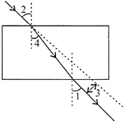  a) 2, 1, 3, 4  b) 1, 2, 1, 4, 3  c) 2, 4, 1, 3  d) 2, 1, 4, 3 | [1]
44 | While performing the experiment on tracing the path of a ray of light passing through a glass slab as shown in the given diagram, four students interpreted the results as given below. Which one of the four interpretations in correct? 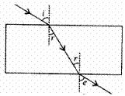  a) $∠$ r = $∠$ e  b) $∠$ i = $∠$ r  c) $∠$ r > $∠$ e  d) $∠$ i > $∠$ r | [1]
45 | Select from the following the best experimental set - up for tracing the path of a ray of light passing through a rectangular glass slab: 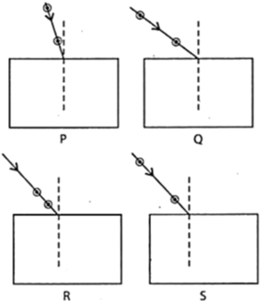  a) P  b) S  c) R  d) Q | [1]
46 | The value of n for the incident ray through air medium is: 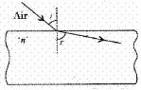  a) > 3  b) < 1  c) = 1  d) > 1 | [1]
47 | On regular reflection from the surface XY, the reflected ray will go along: 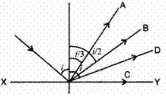  a) A  b) D  c) B  d) C | [1]
48 | The figure shows a ray of light as it travels from medium A to medium B. Refractive index of medium B with respect to medium A is : 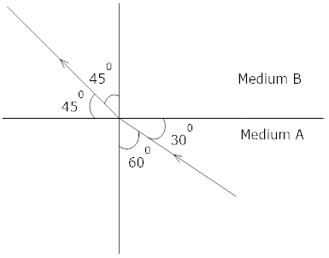  a) $\frac{1}{\sqrt{2}}$  b) $\frac{\sqrt{2}}{\sqrt{2}}$  c) $\frac{\sqrt{3}}{\sqrt{2}}$  d) $\frac{\sqrt{2}}{\sqrt{3}}$ | [1]
49 | A student, while doing the experiment, on tracing the path of a ray of light passing through a rectangular glass slab, measured the three angles marked asθ$​_{1}$ ,θ $​_{2}$ andθ $​_{3}$ in the figure. His measurements could be correct if he were to find: 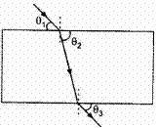  a) θ$​_{1}$ > θ $​_{2}$ but θ $​_{2}$ = θ $​_{3}$  b) θ$​_{1}$ > θ $​_{2}$ > θ $​_{3}$  c) θ$​_{1}$ < θ $​_{2}$ but θ $​_{1}$ = θ $​_{3}$  d) θ$​_{1}$ < θ $​_{2}$ < θ $​_{3}$ | [1]
 | Section C
50 | Which of the following statements is true?  a) A concave lens has 4 dioptre power having a focal length 0.25 m  b) A concave lens has - 4 dioptre power having a focal length of 0.25 m  c) A convex lens has –4 dioptre power having a focal length 0.25 m  d) A convex lens has 4 dioptre power having a focal length 0.25 m | [1]
51 | Find the incorrect statement:  - Convex mirrors are used by the dentist to see the large images of teeth of patients.  - Convex mirrors are used as rear - view mirrors in cars, motorcycles, scooters,etc  - Concave mirrors are used for shaving purpose.  - Concave mirrors are used by doctors to focus light inside the ear or inside the mouth for medical examination.  a) (C)  b) (A)  c) (B)  d) (D) | [1]
52 | Which of the following statement is/aretrue?  - The speed of all colours is the same in air or vacuum.  - The speed of all colours is different in denser media.  - Speed of light in air is 3$×$ 10 $​^{8}$ ms $​^{−1}$ .  - Refractive index has no unit.  a) A and B  b) A, B and C  c) B and D  d) All of these | [1]
53 | Which of the following statement is incorrect?  - A ray of light passing from an optically rarer medium to an optically denser medium bends away from the normal.  - A ray of light passing from an optically denser medium to an optically rarer medium bends away from the normal.  - A ray of light passing from an optically rarer medium to an optically denser mediumbends toward the normal.  - A ray light passing from an optically denser medium to an optically rarer mediumbends towards the normal.  a) A and D  b) B and C  c) A and C  d) A, B and D | [1]
 | Section D
54 | A student focuses the image of a candle flame on a white screen by placing the flame at various distances from a convex lens. He noted his observation in the following table : 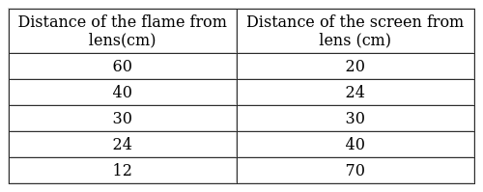  What is the focal length of convex lens?  a) 20  b) 15  c) 12  d) 30 | [1]
55 | In an experiment to trace the path of a ray of light passing through a rectangular glass slab, four students tabulated their observations as given below: 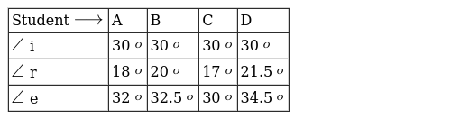  Which student performed the experiment most correctly  a) B  b) C  c) D  d) A | [1]
56 | For the given data showing object distance and focal length of three concave mirrors, answer the following question : 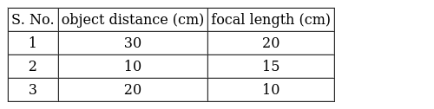  Which mirror is being used as a make - up mirror?  a) Case II  b) Case I  c) Case III  d) Case I and III | [1]
57 | An experiment to trace the path of a ray of light through a glass slab was performed by four students I, II, III and IV. They reported the following measurements of angle of incidence i, angle of refraction r and angle of emergence e. Which one of the students has performed the experiment correctly? 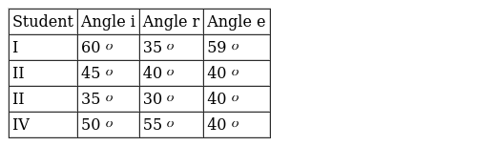  a) III  b) I  c) II  d) IV | [1]
 | Section E
58 | A student performs an experiment on finding the focal length of a convex lens by keeping a lighted candle on one end of laboratory table, a screen on its other end and the lens between them as shown in the figure. The positions of the three are adjusted to get a sharp image of the candle flame on the screen.If now the candle flame were to the replaced by a distant lamp on a far away electric pole, the student would be able to get a sharp image of this distant lamp on the screen by moving 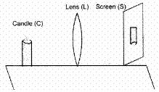  a) the screen in the direction of the lens or the lens away from the screen  b) neither the screen nor the lens  c) the screen in the direction of the lens or the lens in the direction of the screen  d) the screen away fro the lens or the lens in the direction of the screen | [1]
59 | In an experiment on tracing the path of a ray of light through a rectangular glass slab, four students A, B, C, D, used the following values of angle of incidence and the distance between the feet of the two pins (fixed on the incident ray):  - (20$​^{o}$ , 45 $​^{o}$ , 60 $​^{o}$ ) and 1 cm  - (30$​^{o}$ , 45 $​^{o}$ , 60 $​^{o}$ ) and 6 cm  - (20$​^{o}$ , 50 $​^{o}$ , 80 $​^{o}$ ) and 10 cm  - (20$​^{o}$ , 50 $​^{o}$ , 80 $​^{o}$ ) and 15 cm  Out of these, the best choice is that of student:  a) D  b) C  c) A  d) B | [1]
60 | A student has to perform an experiment on tracing the path of a ray of light passing through a rectangular glass slab for three different angles of incidence. Four of his friends suggest the following options to him:  - Draw the incident rays corresponding to 20$​^{o}$ , 50 $​^{o,}$ and 70 $​^{o}$ as the angles of incidence and fix the two pins on the incident rays just 2 cm apart.  - Draw the incident rays corresponding to 20$​^{o}$ , 45 $​^{o}$ , and 70 $​^{o}$ as the angles of incidence and fix the two pins on the incident rays nearly 8 cm apart.  - Draw the incident rays corresponding to 30$​^{o}$ , 45 $​^{o,}$ and 60 $​^{o}$ as the angles of incidence and fix the two pins on the incident rays nearly 8 cm apart.  - Draw the incident rays corresponding to 30$​^{o}$ , 45 $​^{o}$ and 60 $​^{o}$ as the angles of incidence and fix the two pins on the incident rays nearly 2 cm apart.  The best option that he should follow is the option  a) C  b) A  c) B  d) D | [1]
61 | On the basis of their experiment to trace the path of a ray of light passing through a rectangular glass slag four students arrived at the following interpretations:  - The angle of incidence is greater than the angle of emergence  - The angle of emergence is less than the angle of refraction  - Emergent ray is parallel to the incident ray  - Emergent ray is parallel to the refracted ray  The correct interpretation is that of the student  a) (A)  b) (B)  c) (C)  d) (D) | [1]
62 | A student has to do the experiment, on finding the focal length of a given concave mirror, by using a distant object. Out of the following setups (A, B, C, D) available to her  - a screen, a mirror holder and a scale  - a mirror holder, a screen holder and a scale  - a screen holder and a scale  - a mirror holder and a screen holder  a) D  b) C  c) A  d) B | [1]
63 | The rear view mirror of a car is a plane mirror. A driver is reversing his car at a speed of 2 m/s. The driver sees in his rear view mirror the image of a truck parked behind his car. The speed at which the image of the truck appears to approach the driver will be:  a) 4 m/s  b) 2 m/s  c) 1 m/s  d) 8 m/s | [1]
64 | While performing an experiment on determining the focal length of a convex lens, a student obtains a sharp inverted image of the laboratory window grill on the screen and measures the distance d between the screen and the lens. She then repeats the experiment and takes a distant tree as the object in the second case. In order to get a sharp image on the screen, she will now need to move the screen:  a) very close to the lens  b) slightly nearer to the lens  c) very far away from the lens  d) slightly farther away from the lens | [1]
65 | In an experiment to determine the focal length of a convex lens, a student obtained a sharp inverted image of a distant tree on the screen behind the lens. She then removed the screen and looked through the lens in the direction of the object. She will see:  a) an inverted image of the tree at the focus of the lens  b) an erect image of the tree on the lens  c) a blurred image on the wall of the laboratory  d) no image as the screen has been removed | [1]
66 | A student carries out the experiment of tracing the path of a ray of light through a rectangular glass slab, for two different values of angle of incidence:$∠$ i = 30 $​^{o}$ and $∠$ i = 45 $​^{o}$ . The set of values of the angle of refraction ( $∠$ r) and the angle of emergence ( $∠$ e ), she is likely to observe in the two cases, are:  a)  [  $∠$ r = 30 $​^{o}$ , $∠$ e = 20 $​^{o}$  ]  and  [  $∠$ r = 25 $​^{o}$ , $∠$ e = 45 $​^{o}$  ]  b)  [  $∠$ r = 20 $​^{o}$ , $∠$ e = 30 $​^{o}$  ]  and  [  $∠$ r = 45 $​^{o}$ , $∠$ e = 28 $​^{o}$  ]  c)  [  $∠$ r = 30 $​^{o}$ , $∠$ e = 20 $​^{o}$  ]  and  [  $∠$ r = 45 $​^{o}$ , $∠$ e = 28 $​^{o}$  ]  d)  [  $∠$ r = 20 $​^{o}$ , $∠$ e = 30 $​^{o}$  ]  and  [  $∠$ r = 25 $​^{o}$ , $∠$ e = 45 $​^{o}$  ] | [1]
67 | A teacher gives a convex lens and a concave mirror of the focal length of about 20 cm each to his student and asks him to find their focal lengths by obtaining the image of a distant object. The student uses a distant tree as the object and obtains its sharp image, one by one, on a screen. The distances d$​_{1}$ and d $​_{2}$ between the lens/mirror and the screen in the two cases and the nature of their respective sharp images are likely to be:  a) (20 cm, 20 cm) and (inverted, inverted)  b) (20 cm, 40 cm) and (erect, erect)  c) (20 cm, 40 cm) and (inverted, erect)  d) (20 cm, 20 cm) and (erect, inverted) | [1]
68 | A student suggested the following guidelinesto his friend for doing the experiment on tracing the path of a ray of light, passing through a rectangular glass slab, for three different angles of incidence:  - Draw the outlineof the glass slab at three positions on the drawing sheet.  - Draw normalson the top side of these outlinesnear their left end.  - Draw the incident rays on the three outlinesin directions making angles of 30$​^{o}$ , 45 $​^{o}$ , 60 $​^{o}$ with the normal drawn.  - Look for the images of the feetof these pins while fixing two pins, from the other side, to get the refracted ray.  When he showed these guidelines to his teacher, the teacher told him that two of them need to be corrected and modified. These two guidelinesare:  a) D and A  b) C and D  c) B and C  d) B and D | [1]
69 | Suppose you have focussed on a screen the image of candle flame placed at the farthest end of the laboratory table using a convex lens. If your teacher suggests you to focus the parallel rays of the sun, reaching your laboratory table, on the same screen, what you are expected to do is to move the:  a) lens slightly towards the sun  b) lens and screen both towards the sun  c) lens slightly towards the screen  d) lens slightly away from the screen | [1]
70 | Your school lab has one large window. To find the focal length of a concave mirror using one of the walls as the screen, the experiment may be performed:  a) only on the table as per the lab arrangement.  b) on the wall adjacent to the window.  c) on the same wall as the window.  d) near the wall opposite to the window. | [1]
71 | A student obtained a sharp image of the grill of a window on a screen, using a convex lens. For getting better results, the teacher suggested focusing on a distant tree instead of the grill. In which the direction should the lens be moved for this purpose?  a) towards the screen  b) very far away from the screen  c) away from the screen  d) behind the screen | [1]
72 | For the experiment on finding the focal length of a convex lens by obtaining the image of a distant object, a laboratory assistant keeps the following apparatus on the table:  - A stand with a metal needle fixed in it  - A stand with the given convex lens fitted in it  - A thick cardboard white screen  - A metre scale  A student can do the experiment by using the apparatus listed as  a) D, A, B  b) B, C, D  c) A, B, C  d) C, D, A | [1]
73 | In the glass slab experiment shown below, four students A, B, C and D did the following:A : kept the eyes far from the glass slab while placing both the pins P $​_{3}$ and p $​_{4}$ B : kept the eyes close to the glass slab while placing both the pins P $​_{3}$ and P $​_{4}$ C : kept the eyes close to the glass slab while placing pin P $​_{3}$ and far from the slab while placing pin P $​_{4}$ D : kept the eyes far from the glass slab while placing pin P $​_{3}$ and close to the slab while placing pin P $​_{4}$ 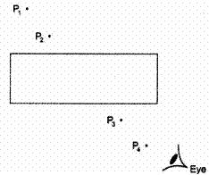  The correct procedure is that of student  a) D  b) B  c) C  d) A | [1]
74 | A student obtained a sharp image of the grill of a window in the laboratory on a screen, using a convex lens. For getting better results, her teacher suggested focusing on a distant tree instead of the grill. In which direction should the lens be moved for this purpose to get a sharp image on the screen?  a) behind the screen  b) very far away from the screen  c) towards the screen  d) away from the screen | [1]
75 | A child is standing in front of a magic mirror. She finds the image of her head bigger, the middle portion of her body of the same size and that of the legs smaller. The following is the order of combinations for the magic mirror from the top.  a) Concave, plane and convex  b) Convex, plane and concave  c) Plane, convex and concave  d) Convex, concave and plane | [1]

